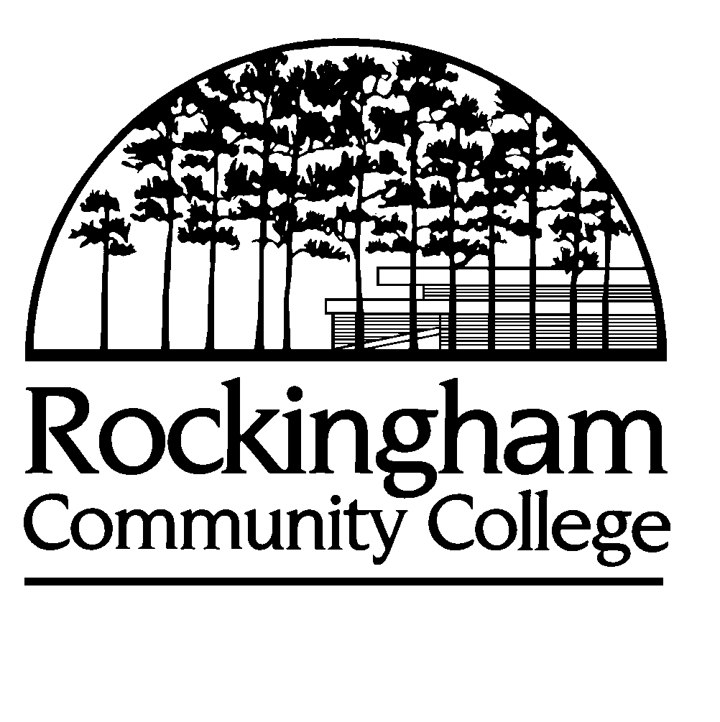

*ROCKINGHAM COMMUNITY COLLEGE*

***NOMINATION FORM***

# *EXCELLENCE IN TEACHING AWARD*

All nomination forms are due to the Vice President for Academic Affairs, Administration Building, Room 108, by 5:00 p.m. on Monday, April 30, 2012.

**Please check nomination box**  **Full-Time Faculty**  **Part-Time Faculty**

Award Criteria:

Selection of award recipients will be based on a letter of nomination, (not to exceed 3 pages) describing the nominee’s qualifications for the award. Each nomination will be reviewed using the following criteria.

The nominee demonstrates:

* support for RCC mission and vision.

1. superior level of teaching effectiveness. Develops innovative teaching techniques and regular application of techniques in the classroom.
2. active and positive record of service to students, as an advisor (full-time faculty only) and mentor.
3. development of innovative course offerings and/or programs of study.
4. service to the college community, participation in professional organizations and community activities.

|  |  |  |  |
| --- | --- | --- | --- |
| Nominee’s Signature: |  | Date: |  |
|  |  |  |  |
|  |  |  |  |
|  |  |  |  |
| Nominator: |  | Date: |  |